Name : Rajvardhan Reddy
Reg No : 180905093
Sec : B
Roll No : 19

Lab 2 : Working with Directory Structures

LAB EXERCISES :

P1)
Code :
#include <stdio.h>
#include <stdlib.h>
#include <unistd.h>
#include <dirent.h>
#include <sys/stat.h>
#include <string.h>
#include <time.h>

int main()
{
char pwd[256];
if(!getcwd(pwd, sizeof(pwd)))
printf("Directory name exceeds size of buffer or is removed or permissions are changed.");
DIR *dp;
struct dirent *entry;
struct stat fileStat;
if((dp = opendir(pwd))==NULL)
printf("Can not open directory.");
else
{
while((entry = readdir(dp))!=NULL)
{
if(strcmp(".", entry->d_name)==0 || strcmp("..", entry->d_name)==0 || entry->d_name[0]=='.') continue;
else
{
printf("%s\t", entry->d_name);
lstat(entry->d_name, &fileStat);
printf((S_ISDIR(fileStat.st_mode)) ? "d" : "-");
printf((fileStat.st_mode & S_IRUSR) ? "r" : "-");
printf((fileStat.st_mode & S_IWUSR) ? "w" : "-");
printf((fileStat.st_mode & S_IXUSR) ? "x" : "-");
printf((fileStat.st_mode & S_IRGRP) ? "r" : "-");
printf((fileStat.st_mode & S_IWGRP) ? "w" : "-");
printf((fileStat.st_mode & S_IXGRP) ? "x" : "-");
printf((fileStat.st_mode & S_IROTH) ? "r" : "-");
printf((fileStat.st_mode & S_IWOTH) ? "w" : "-");
printf((fileStat.st_mode & S_IXOTH) ? "x" : "-");
printf("\t%d",fileStat.st_size);
printf("\t%s",ctime(&fileStat.st_ctime));
}
}
closedir(dp);
}
return 0;
}

Output :

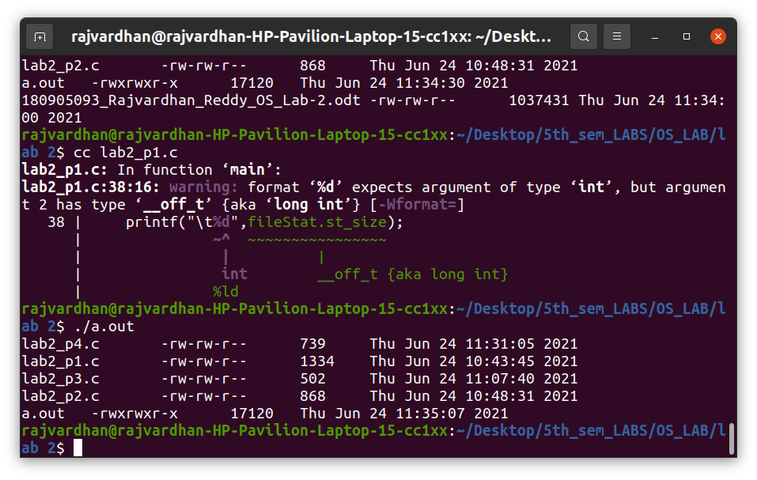

P2)

Code :
#include <unistd.h>
#include <stdio.h>
#include <dirent.h>
#include <string.h>
#include <sys/stat.h>
#include <stdlib.h>

void printdir(char *dir, int depth) {
DIR *dp;
struct dirent *entry;
struct stat statbuf;

if((dp = opendir(dir)) == NULL) {
fprintf(stderr, "Cannot open directory: %s\n", dir);
return;
}
chdir(dir);
while((entry = readdir(dp)) != NULL)
{
lstat(entry->d_name, &statbuf);
if(S_ISDIR(statbuf.st_mode))
{
if(strcmp(".", entry->d_name) == 0 || strcmp("..", entry->d_name) == 0) continue;
printf("%*s%s/\n", depth,"",entry->d_name);
printdir(entry->d_name, depth+4);
}
else
{
printf("%*s%s\n", depth,"", entry->d_name);
}
}
chdir("..");
closedir(dp);
}

int main(int argc, char* argv[])
{
if(argc != 2)
{
printf("Invalid arguments. Only enter required directory.");
}
printdir(argv[1], 0);
return 0;
}

Output :

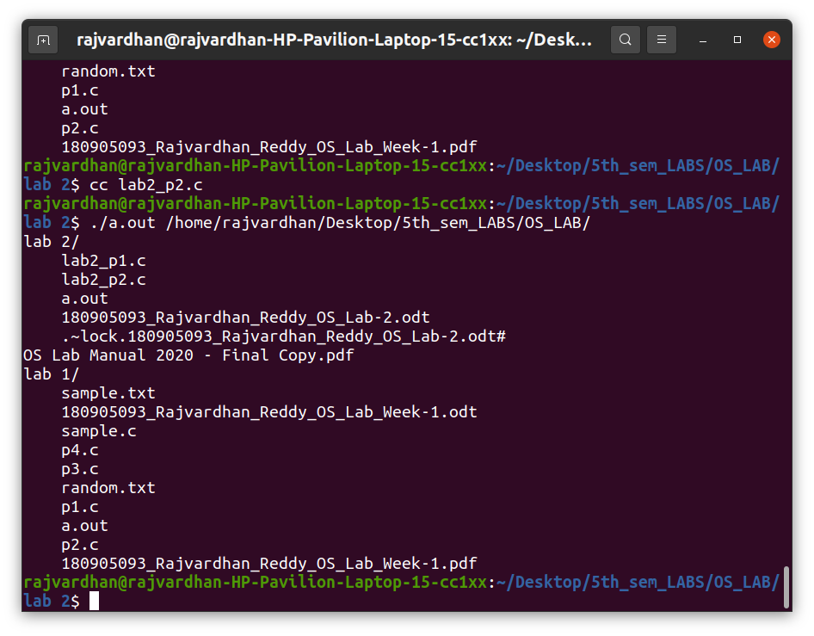

P3) Method-1

Code :

$ apt list –installed

Output :
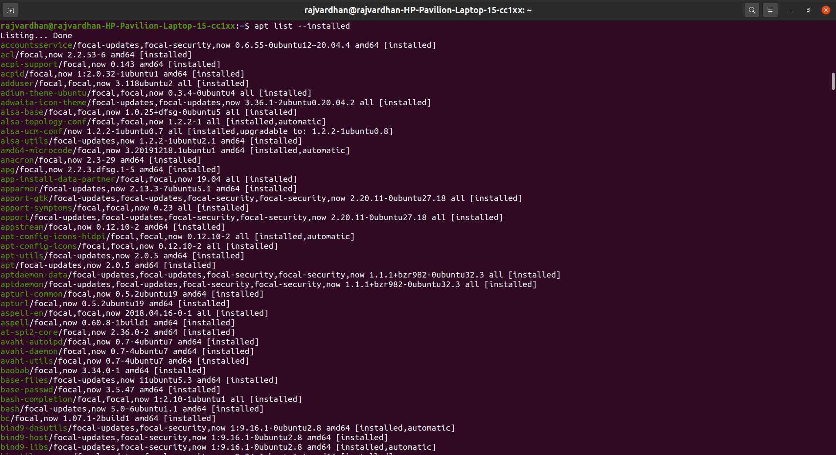

P3) Method-2
Code :
#include <string.h>
#include <sys/types.h>
#include <sys/stat.h>
#include <unistd.h>
#include <stdio.h>
#include <stdlib.h>
#include <dirent.h>
#include <time.h>
#include <pwd.h>
#include <grp.h>

int main(int argc, char* argv[])
{
DIR *dp = opendir(argv[1]);
struct dirent *entry;

while((entry = readdir(dp)) != NULL)
{
if(strcmp(".", entry->d_name) == 0 || strcmp("..", entry->d_name) == 0) continue;
printf("%s\n", entry->d_name);
}
closedir(dp);
}

Output :
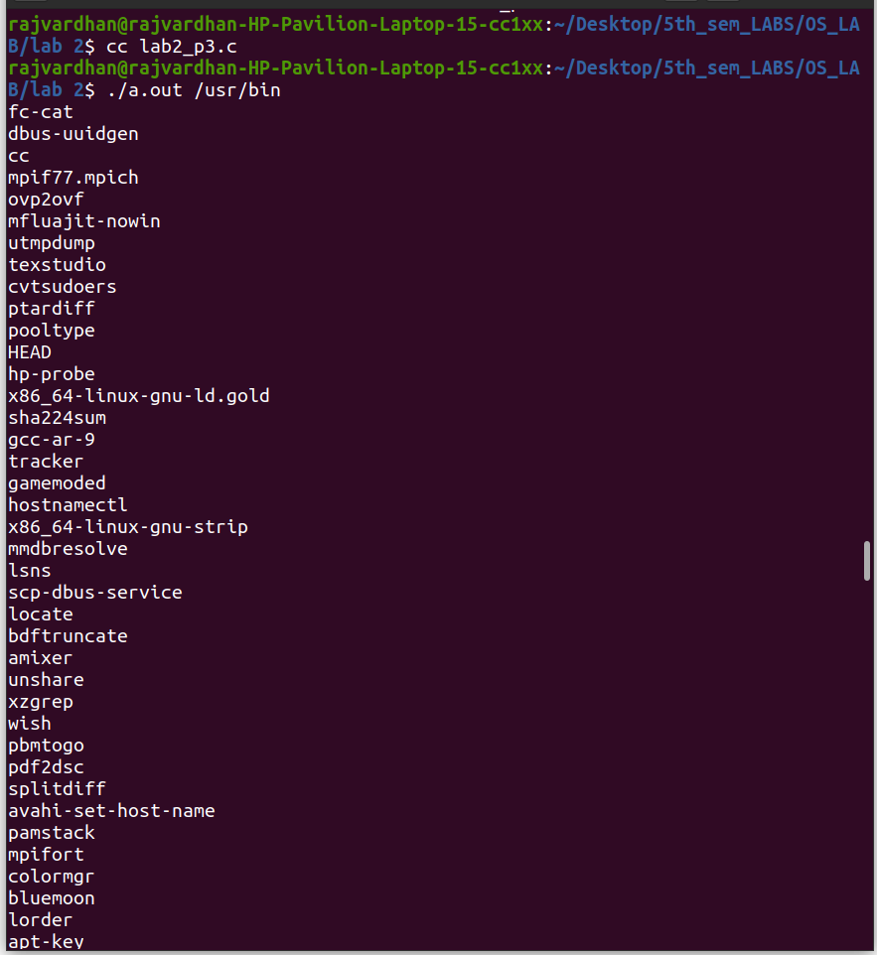
P4)
Code : Method-1
$ rpm -qa

Output :
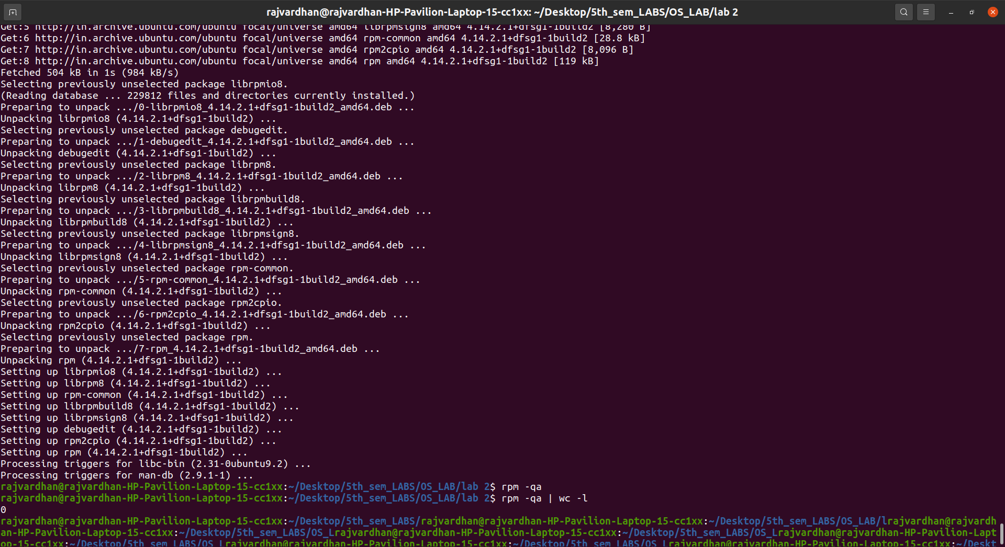

P4)
Code : Method-2
#include <unistd.h>
#include <stdio.h>
#include <dirent.h>
#include <string.h>
#include <sys/stat.h>
#include <stdlib.h>

void printDir(char *dir,int depth)
{
DIR * dp;
struct dirent * entry;
struct stat statbuf;
if((dp = opendir(dir)) == NULL) {
printf("Cannot open directory \n");
return;
}
chdir(dir);
while((entry = readdir(dp)) != NULL) {
lstat(entry->d_name,&statbuf);
if(S_ISDIR(statbuf.st_mode)){
if(strcmp(".",entry->d_name) == 0 || strcmp(".." , entry->d_name ) == 0 )
continue;
printf("%*s%s/\n",depth,"",entry->d_name );
printDir(entry->d_name,depth+4);
}
else{
printf("%*s%s/\n",depth,"",entry->d_name);
}
}
chdir(".");
closedir(dp);
}

int main() {
printDir("/var/lib/dpkg/info",0);
}

Output :

